**Linear Regression with AWS Deployment**

* **About The Project:**
  + This project mainly focused on deployment of linear regression model in **AWS** Cloud.
  + The Linear Regression model is trained on Kaggle’s “Chance of admission” dataset. In this model we predict probability of admission based on following features.
    - GRE Score
    - TOEFL Score
    - University Rating
    - SOP-This feature is about Sop Rating(1-5)
    - LOR-This feature is about LOR Rating(1-5)
    - CGPA
    - Research-Whether student published any research paper or not.
  + Chance of Admit is a dependent feature.
* **Built With:**
  + Python-(3.7)
  + AWS
  + Flask API
  + HTML
* **Prerequisites:**
  + Kindly run following command to install necessary libraries in anaconda prompt**.**
    - **pip install -r requirments.txt**
* **Getting Started**
  + In **train.py** the model is trained and later it is saved in **model.pickle** file.
  + **application.py** contains the code for flask API.
  + **.ebextensions** and **.elasticbeanstalk** contains the configuration files required for cloud deployment.
  + **Templates** and **Static** folder contain all the required html and css files.
* **Cloud URL:**

<http://demo1-env.eba-qq4stint.us-east-2.elasticbeanstalk.com/>

* **Output Screenshots:**

**First Page**

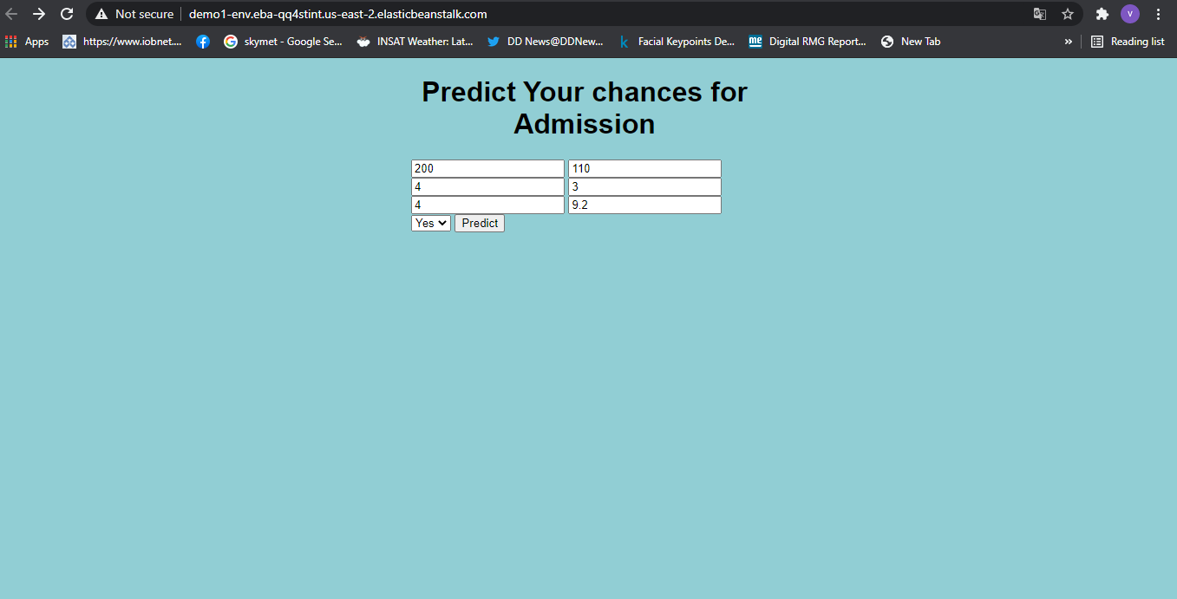

**Second Page.**

